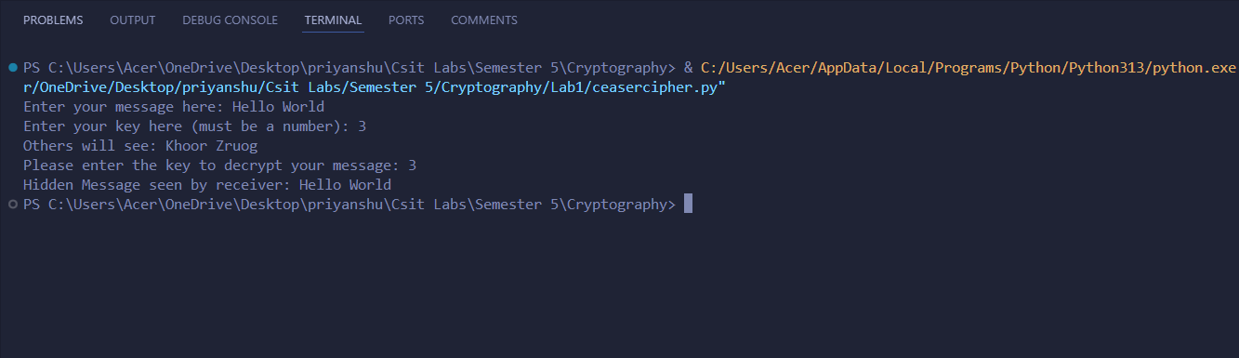
- CeaserCipher Output:

- HillCipher Output:
